**Assignment 2: Rasterization**

**Triangle Soup Editor**

1. **I is pressed(Insertion Mode) and Left button is clicked. A point occurs.**

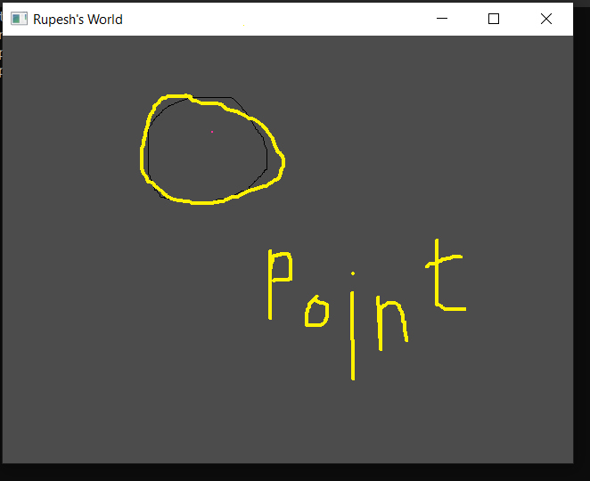

1. **Cursor is moved. A Line occurs.**

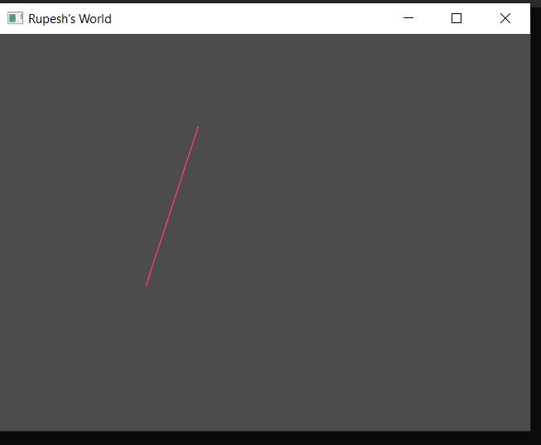

1. **Line positions is finalized, and Left Button is clicked. After which cursor is moved. A Triangle can be seen.**

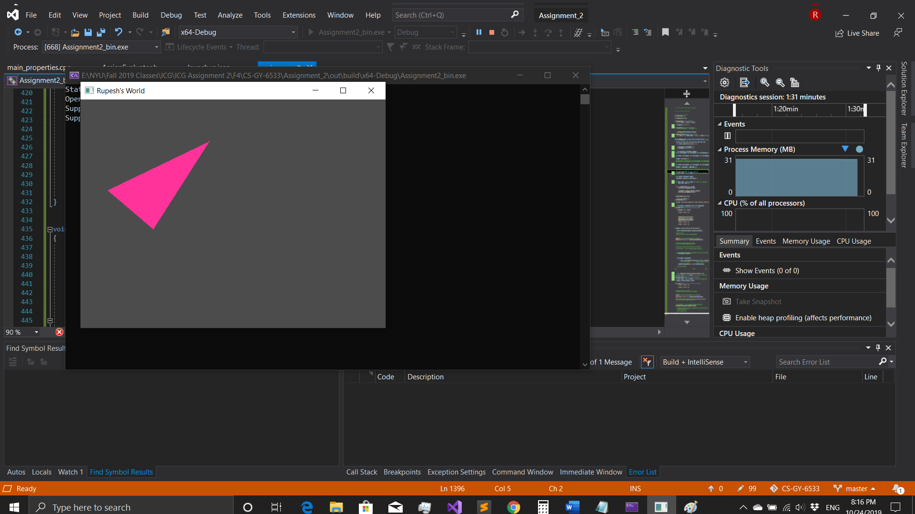

1. **Triangle position is finalized, and Left Button is clicked. A Triangle is drawn. Same steps are repeated for multiple triangles.**

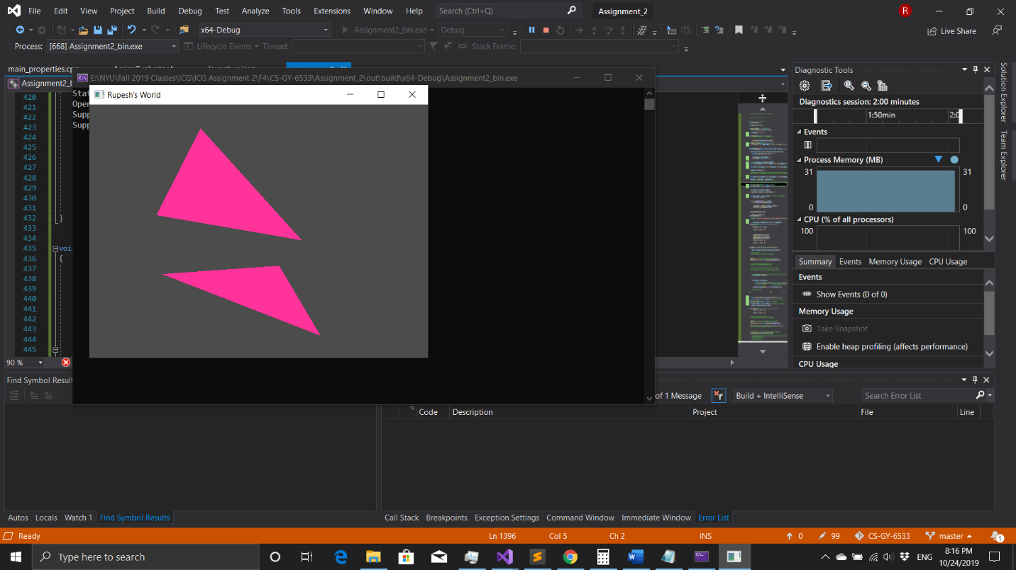

1. **O is pressed (Translation Mode) And a Triangle is selected by clicking mouse left button on a point inside triangle.**

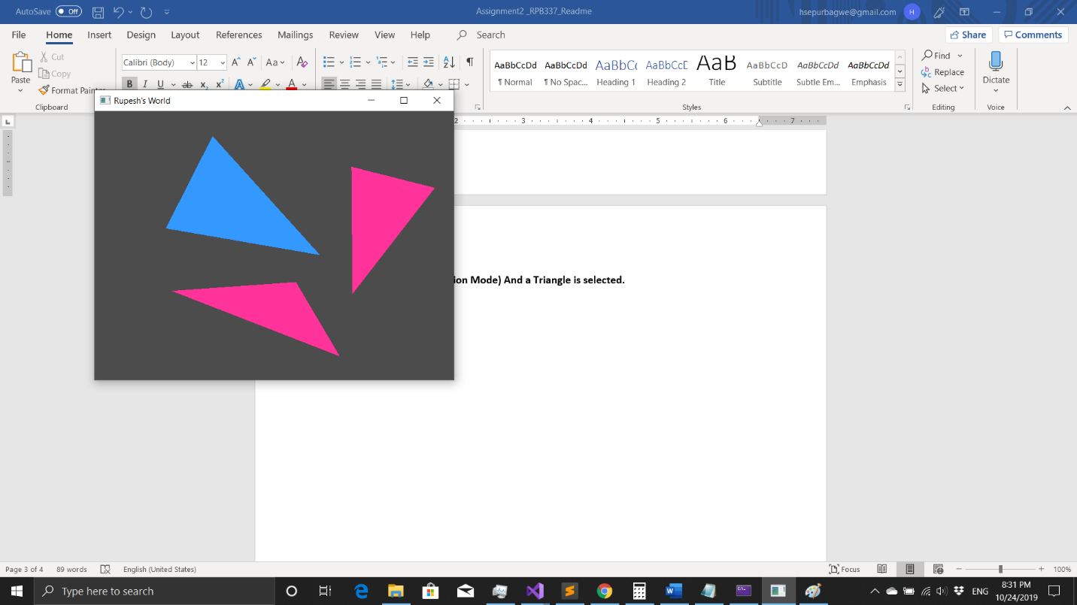

1. **Without releasing mouse button, that triangle is moved to a new position. Distance moved = Point where selected triangle was released - point where triangle was selected.**

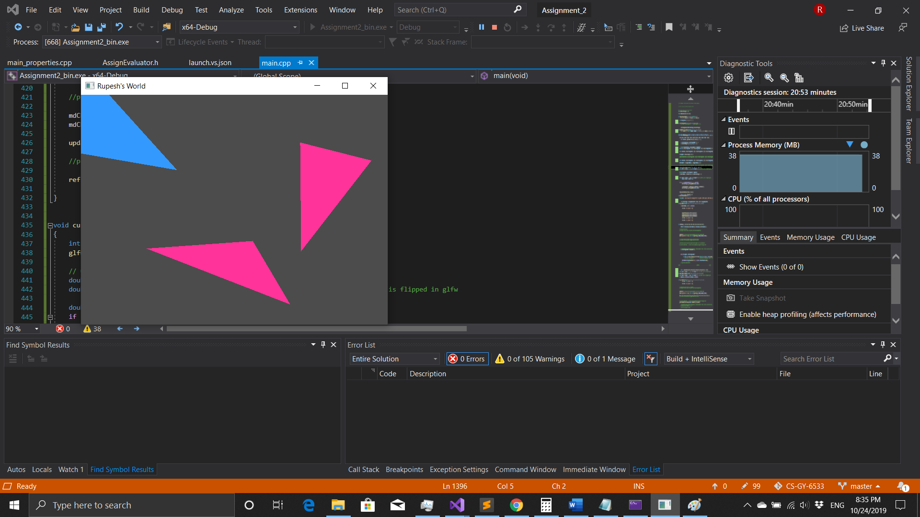

1. **P is pressed (Deletion Mode). And triangle is deleted by clicking on that triangle.**

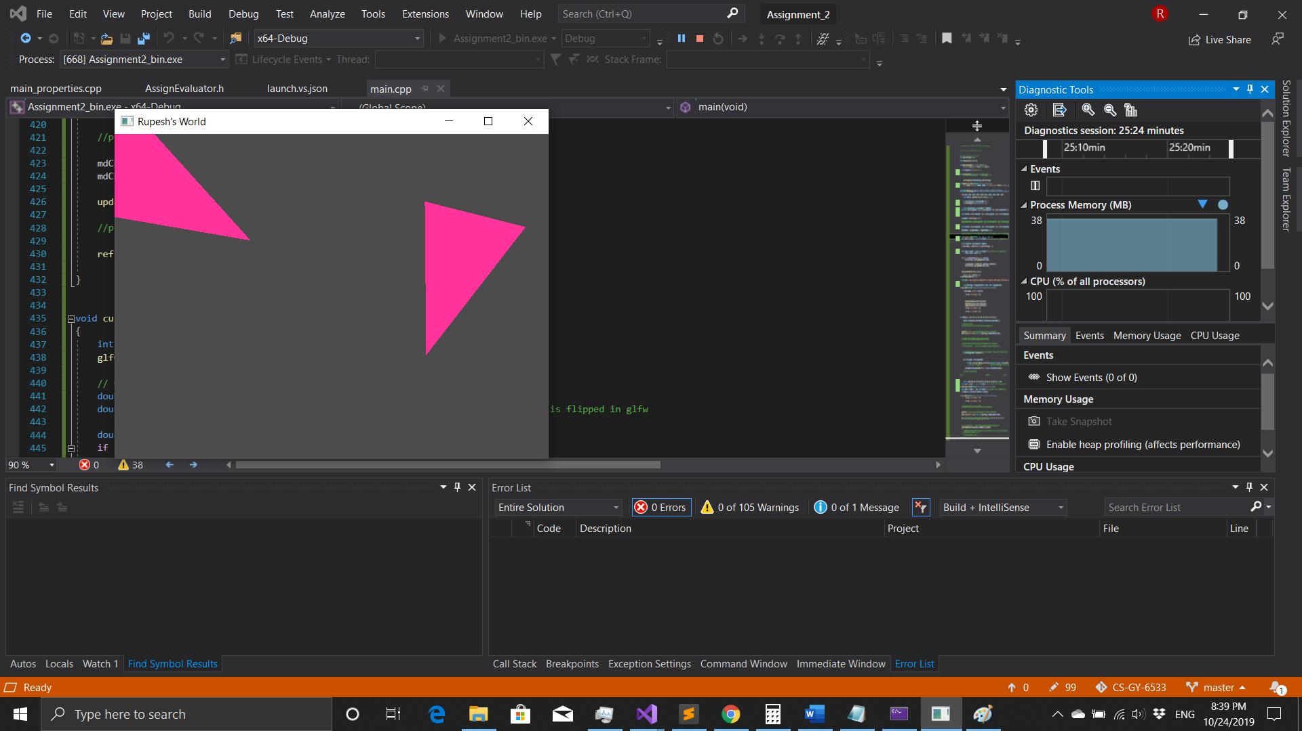

1. **Multiple Triangles can be inserted, translated and deleted.**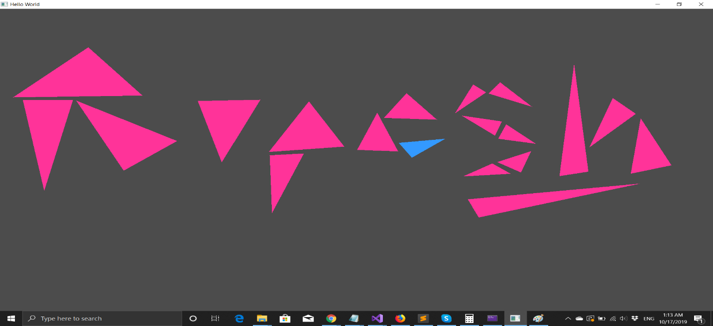

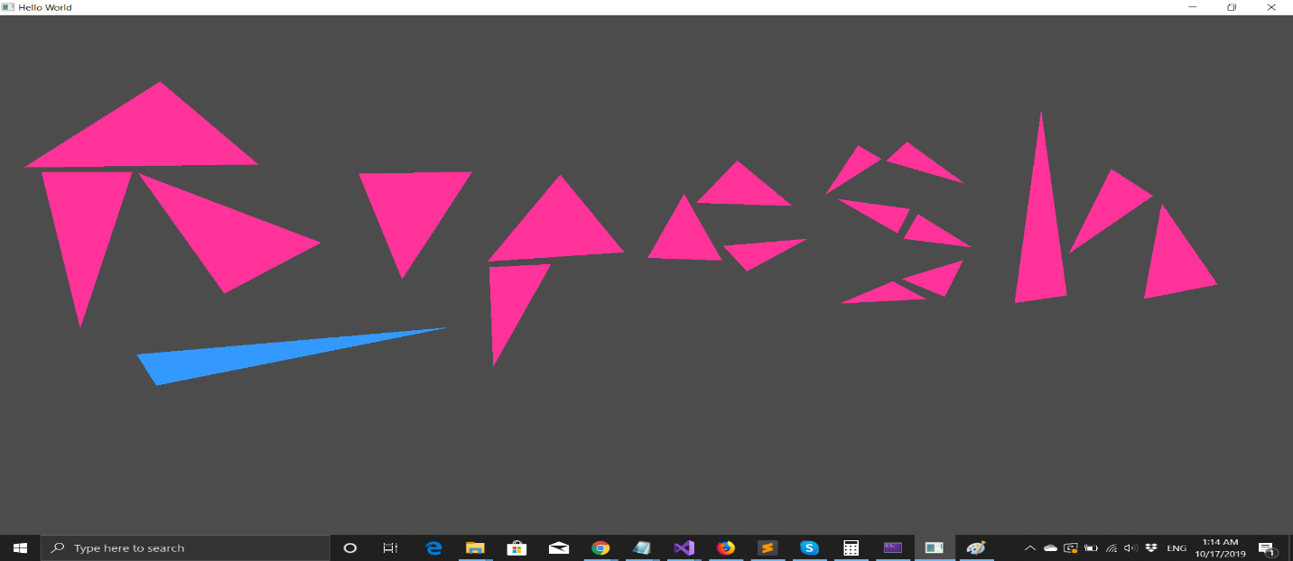

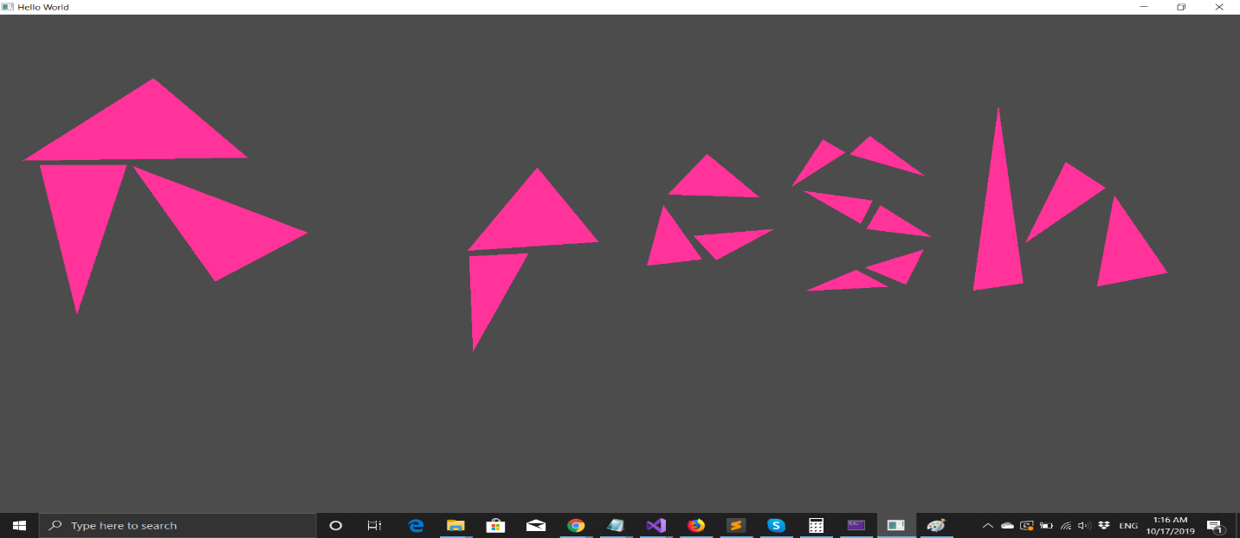

**Rotation/Scale**

1. **Multiple Triangles are drawn in insertion mode. Then O is pressed (translation mode). After which triangle is selected and J is pressed 3 times. So, the selected triangle gets rotated clockwise by 10 degrees for each press, around its barycenter.**

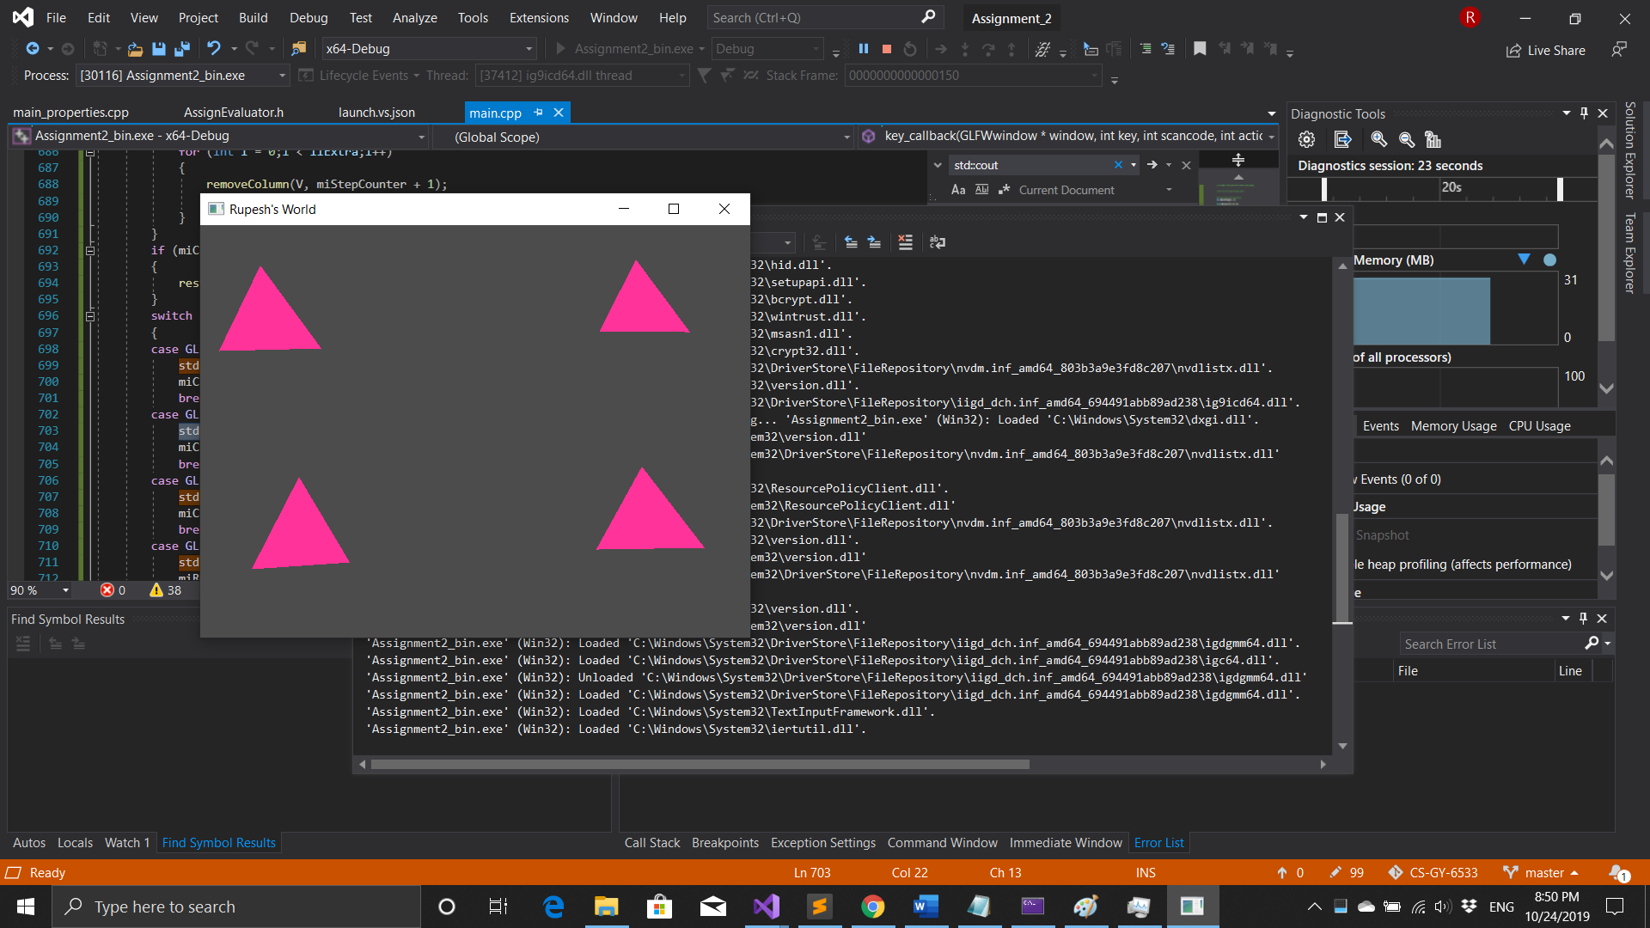

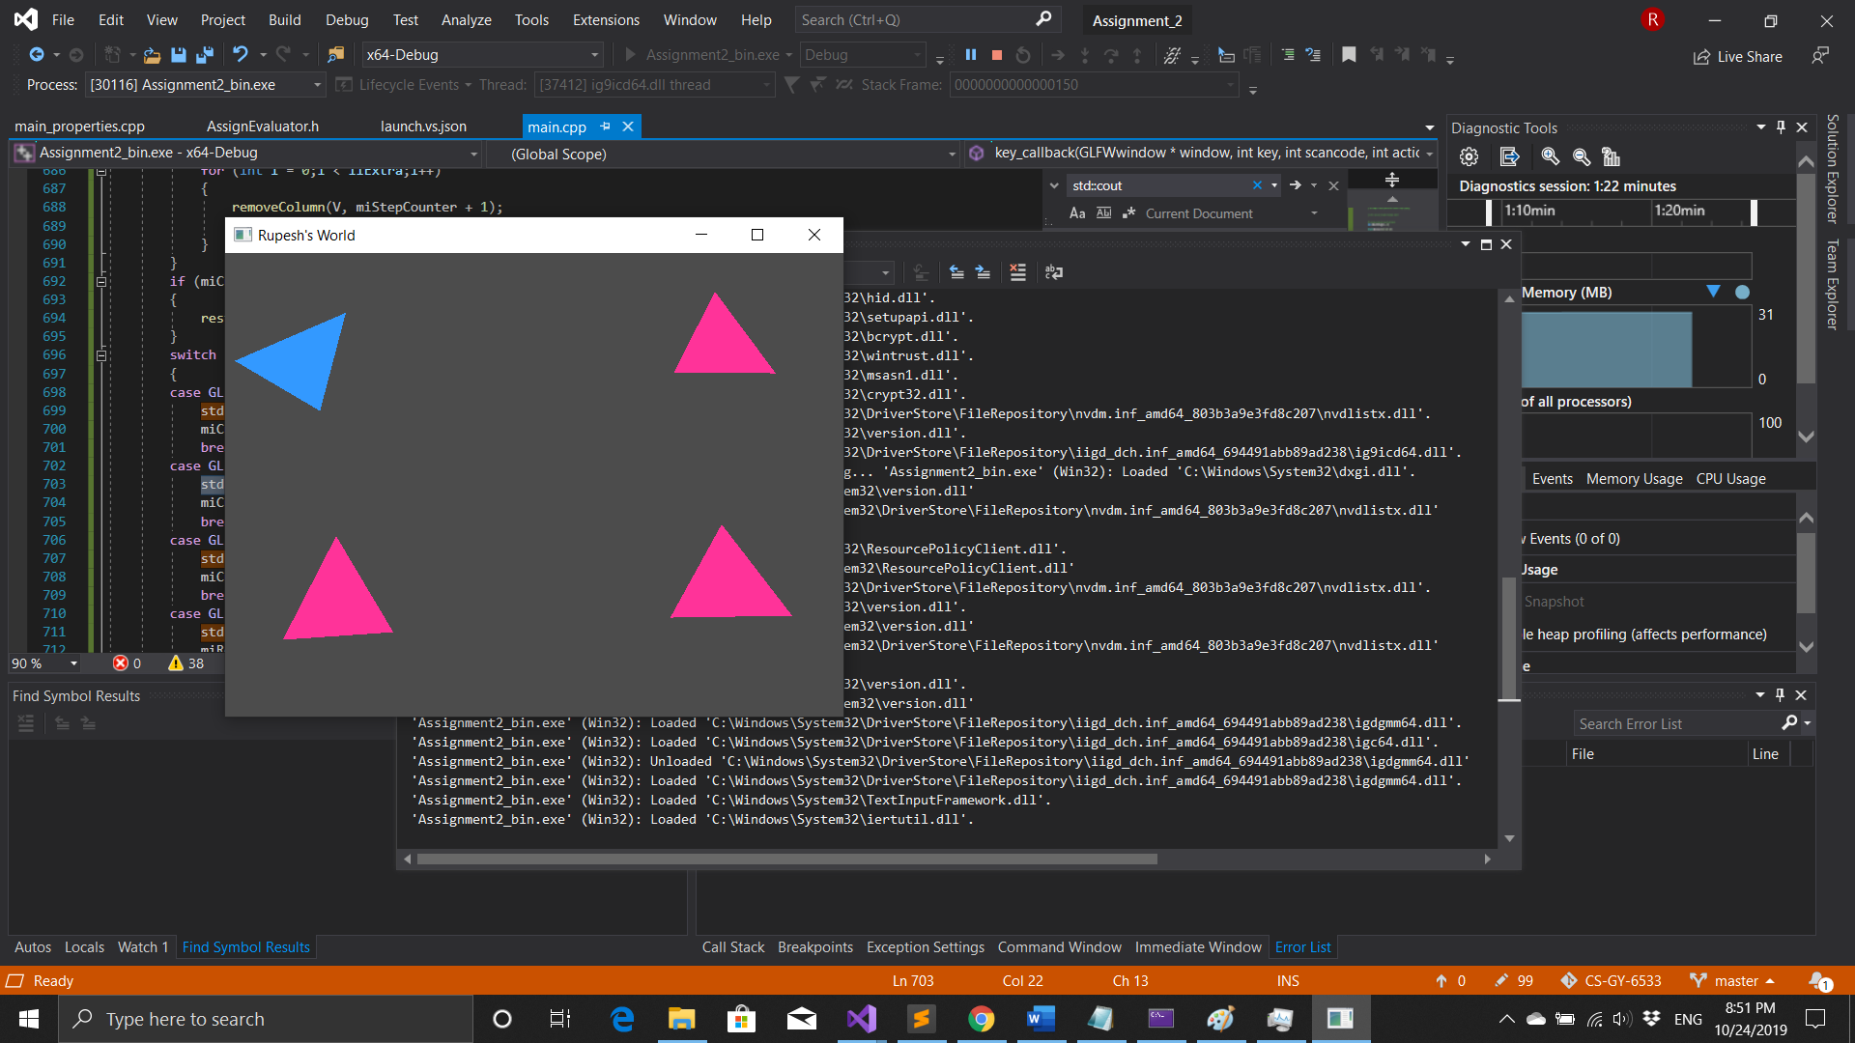

1. **Similarly, other triangle is selected, and h is pressed 3 times, and so the selected triangle gets rotated counterclockwise by 10 degrees for each press, around its barycenter.**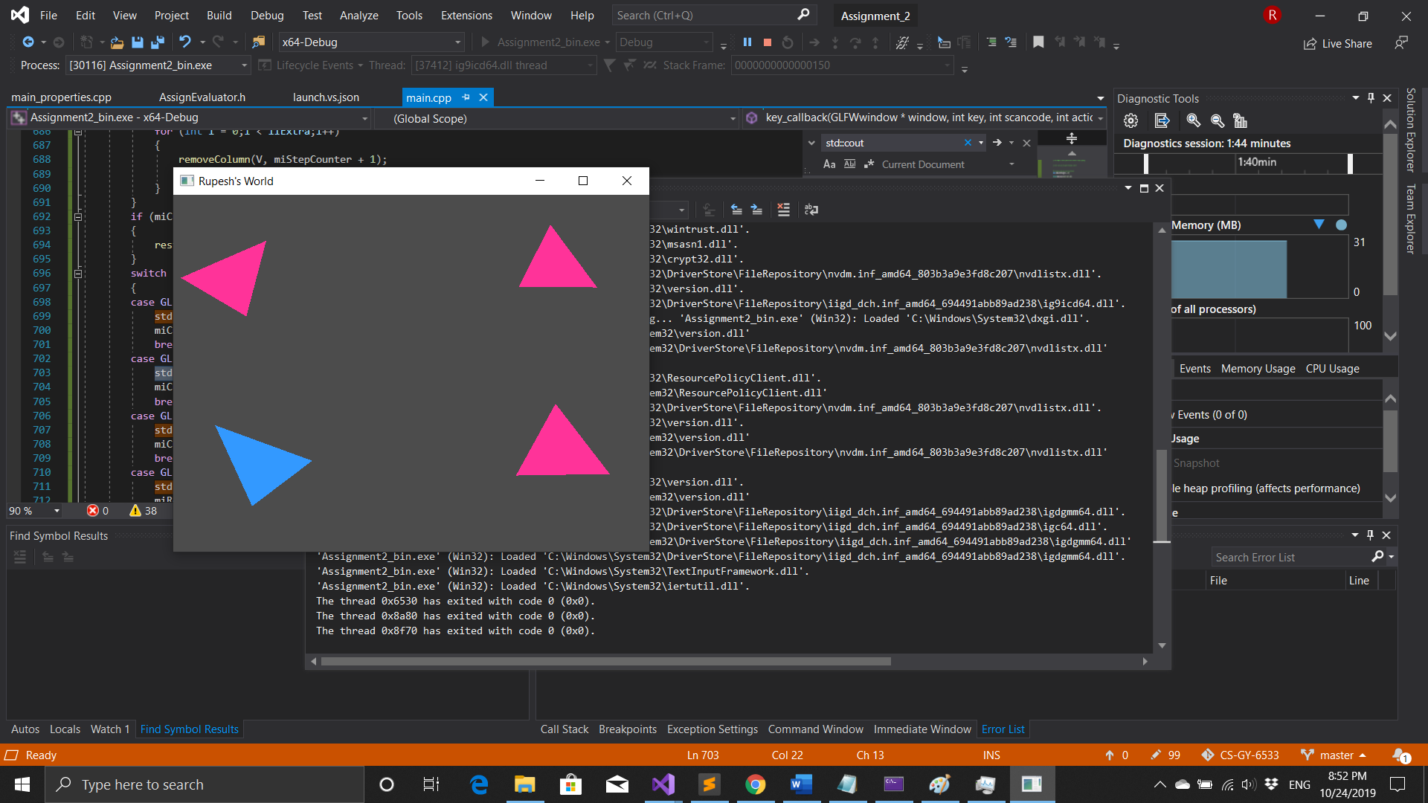
2. **Also, another triangle is selected, and K is pressed and so that triangle gets scaled up by 25% for each press of K.**

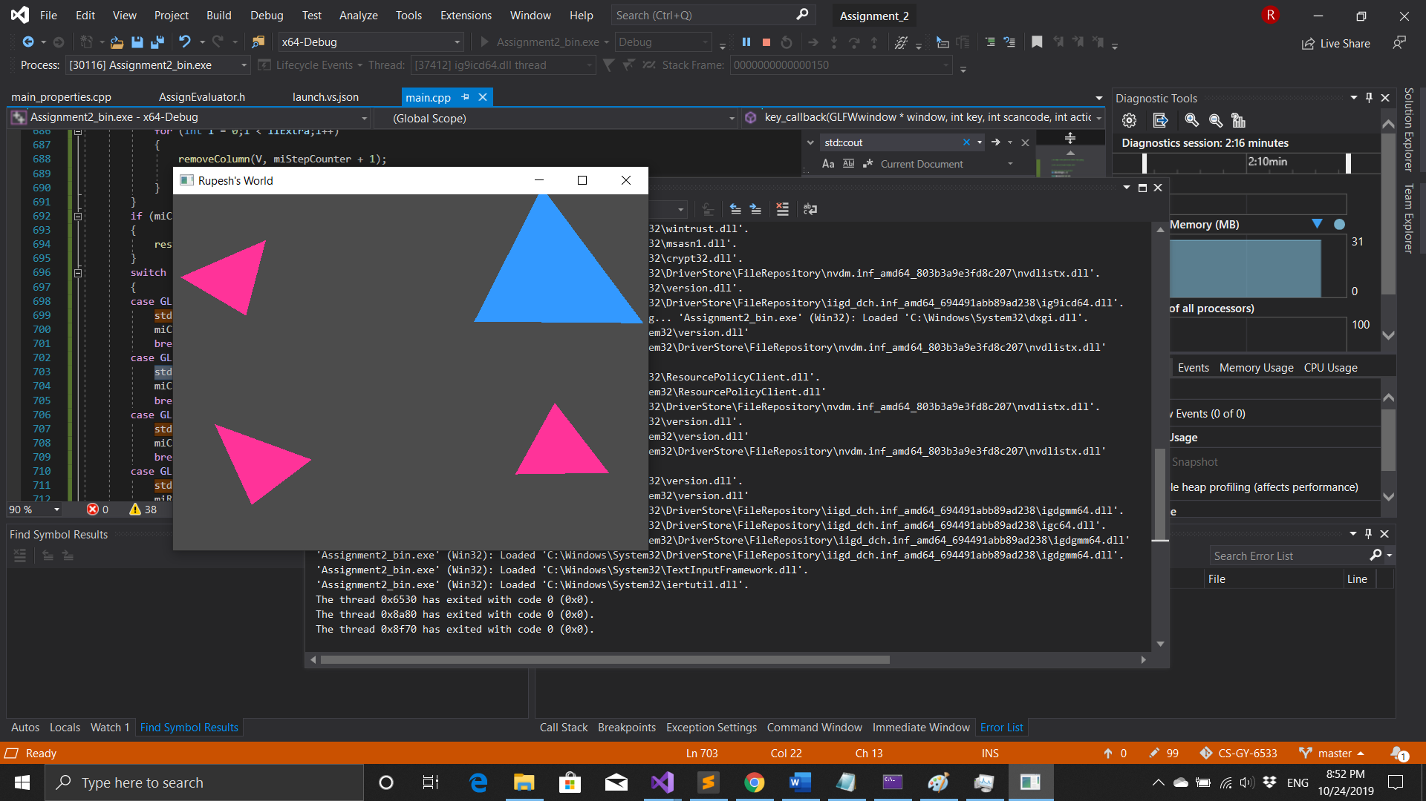

1. **Similarly, the fourth triangle is selected, and L is pressed and it gets scaled down by 25%.**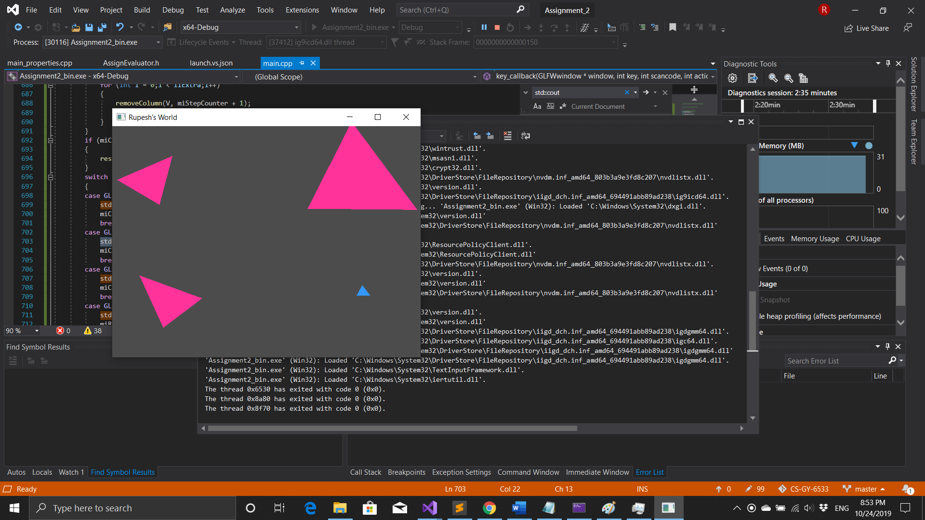

**Color**

1. **Now c is pressed (color mode ) and a vertex is selected by clicking any point closest to that vertex. If click anywhere the nearest vertex is selected. Then any number from 1 to 9 is pressed and the color of that vertex is changed accordingly. Different vertex are selected and their color is changed**

**1 :-** **Green 2:- Blue 3:- White 4:-Orange 5:-DarkGreen 6:-Yellow 7:-Black 8:-Red 9:-LPink**

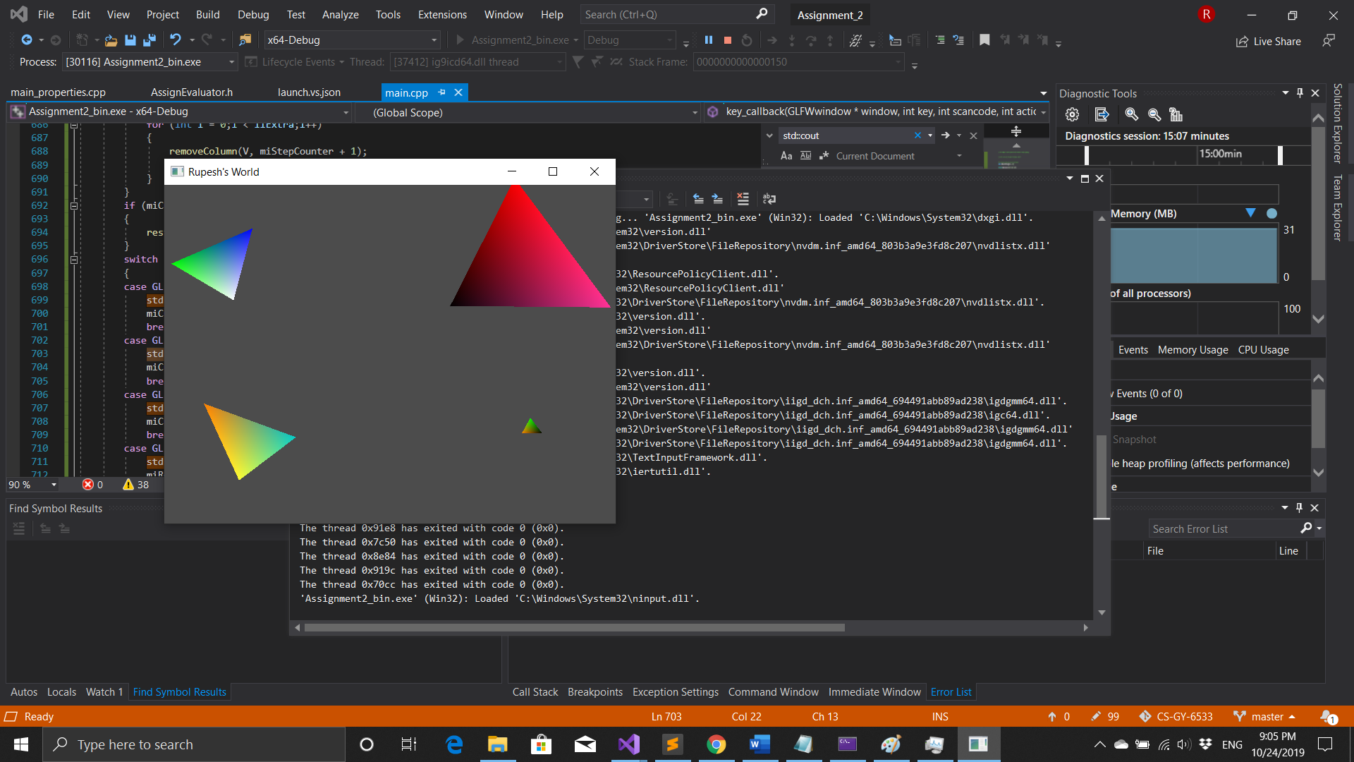

**View Control**

**14)Now ‘w’ is pressed, the screen is translated 20% upwards**

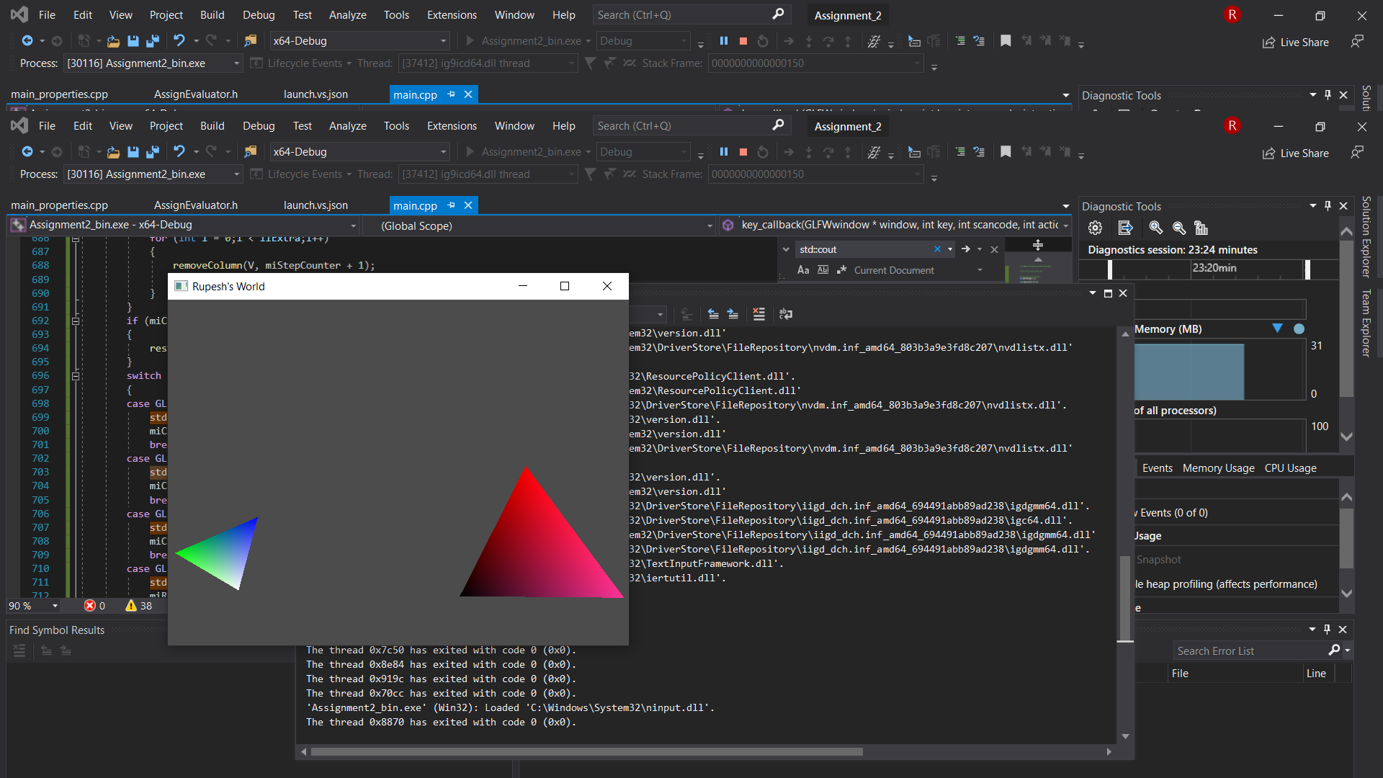

**15)Now ‘a’ is pressed, the screen is translated 20% towards left**

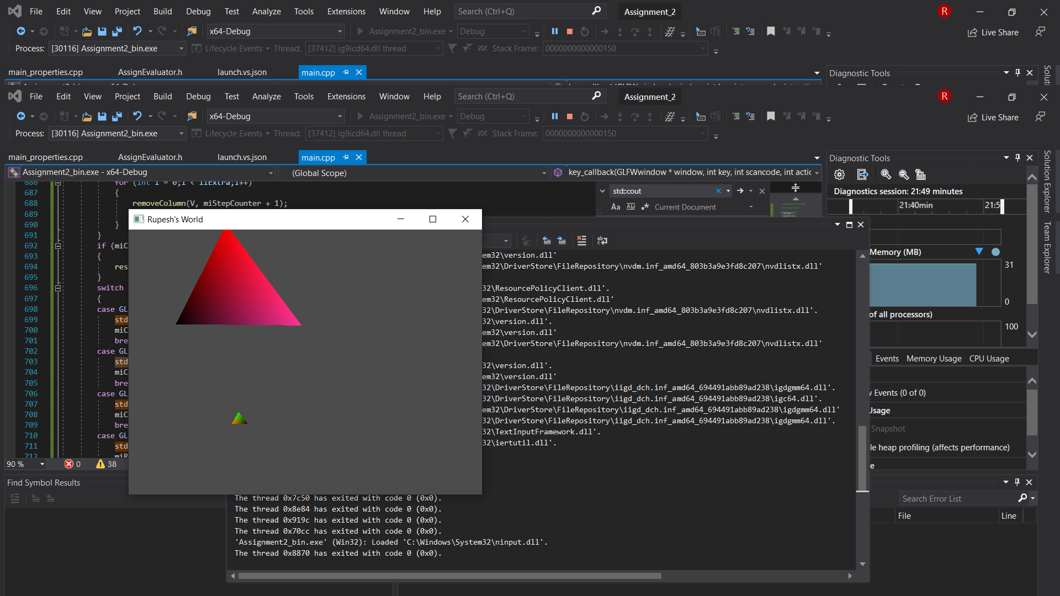

**16)Now ‘s’ is pressed, the screen is translated 20% downwards**

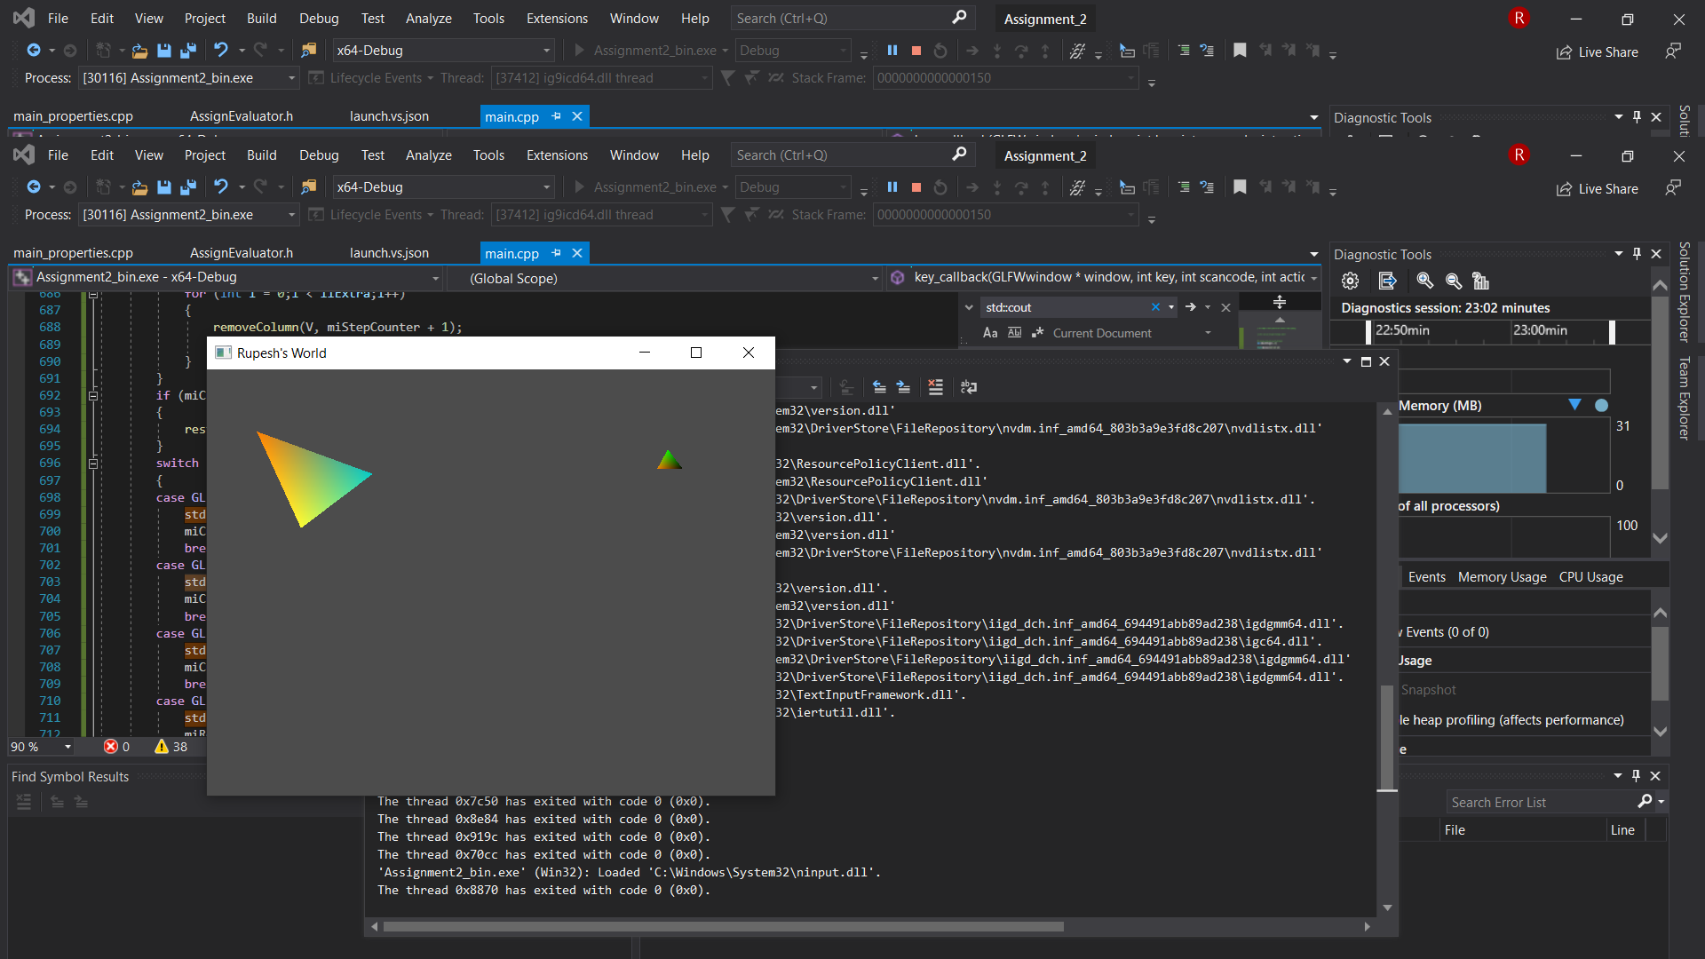

**17)Now ‘d’ is pressed, the screen is translated 20% towards right**

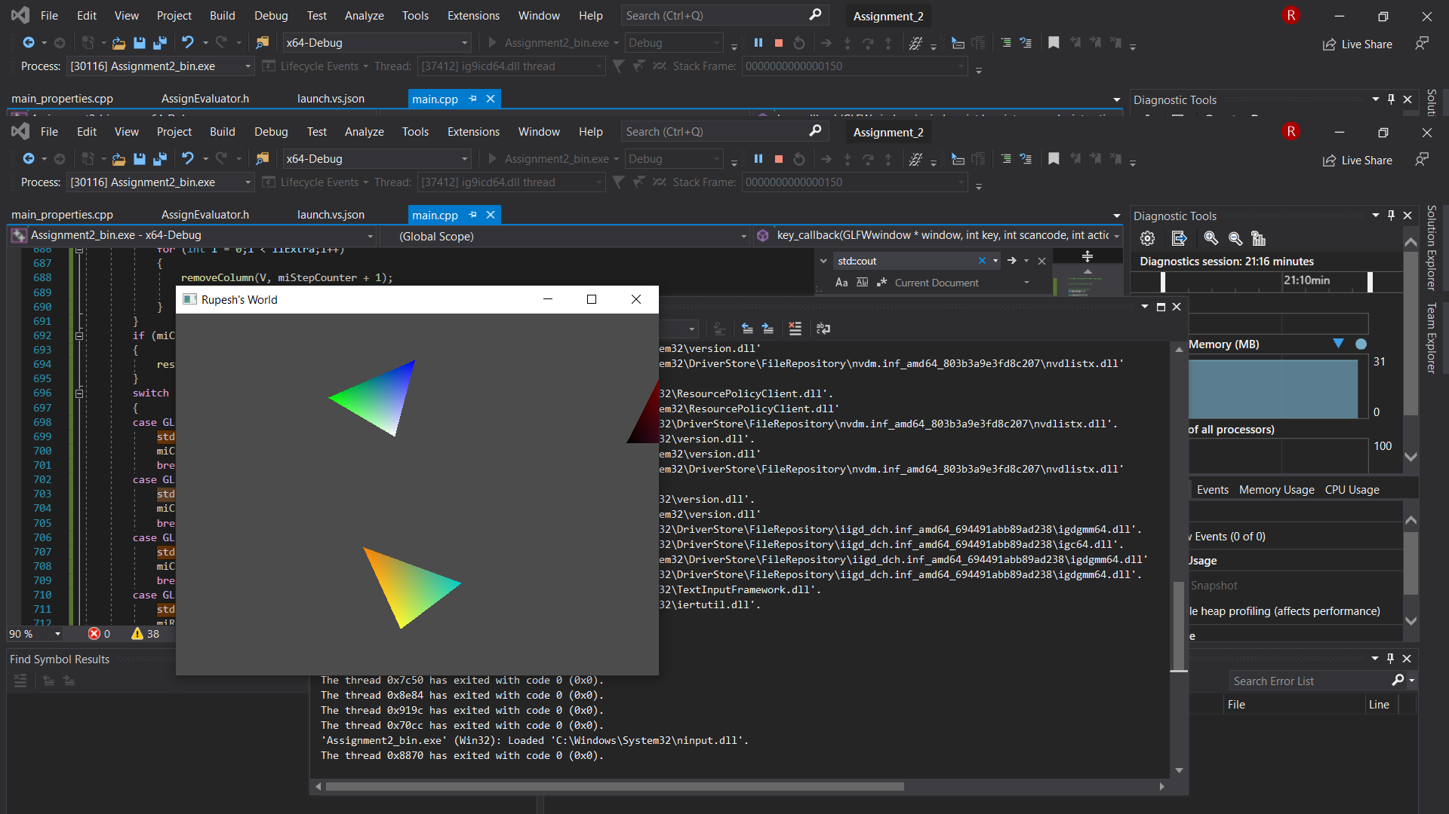

**17)Now ‘+’ is pressed, to zoom in by 20%**

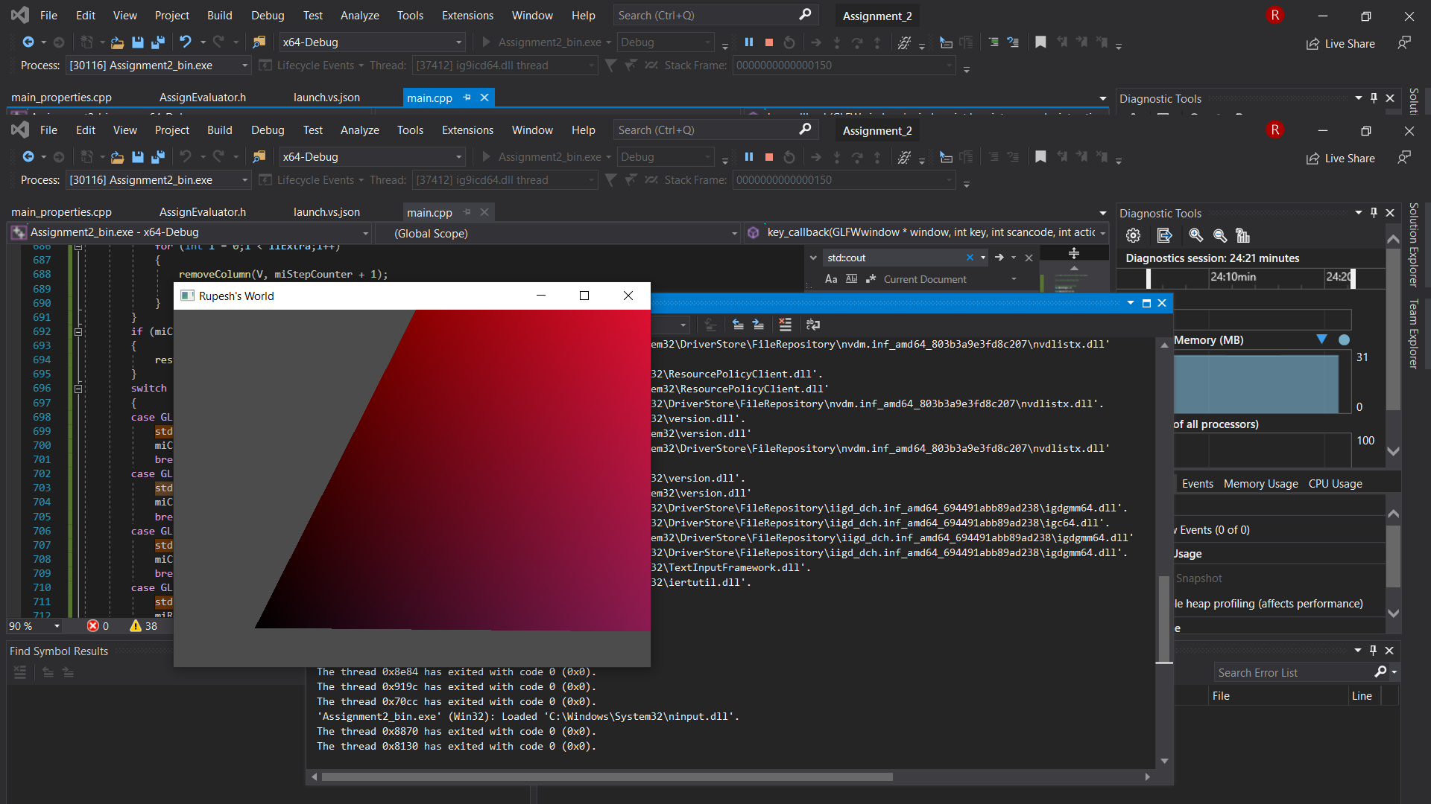

**18)Now ‘-’ is pressed, to zoom out by 20%**

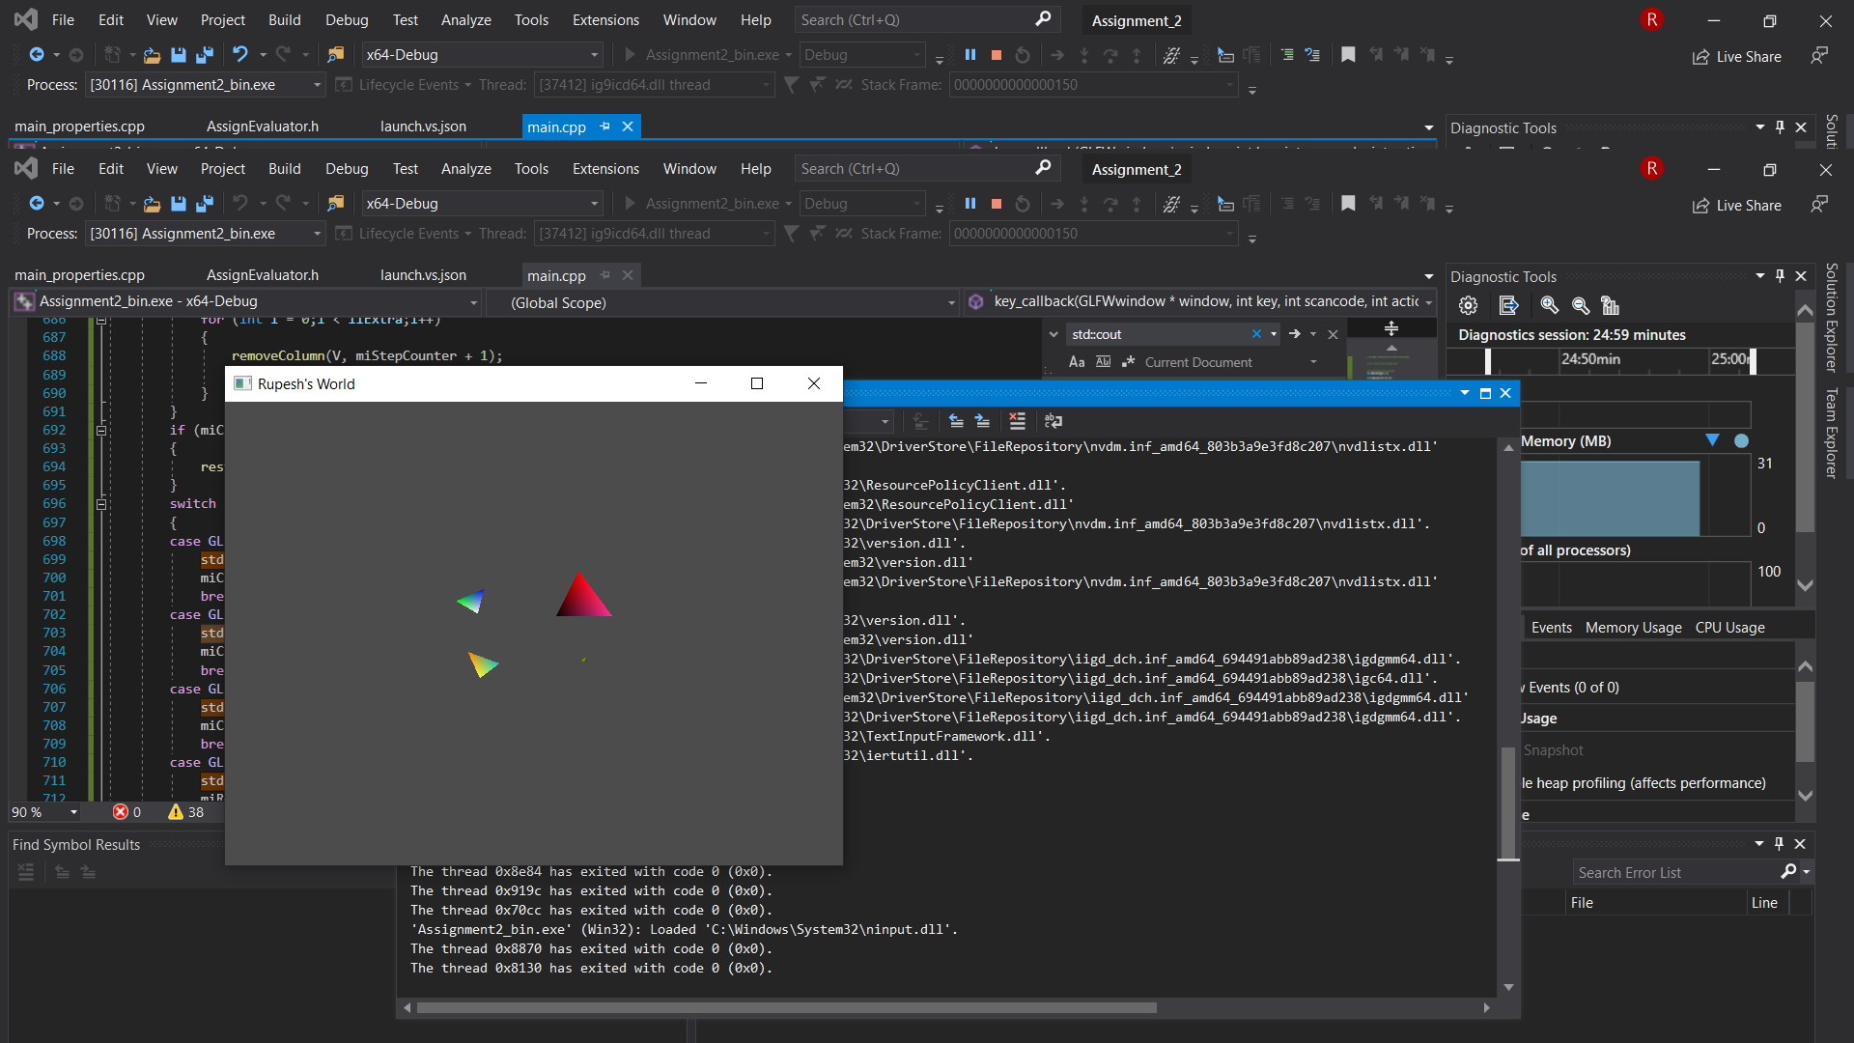

**Key Framing**

**19)** **By pressing ‘r’ the window enters keyframe mode. For each passing second the triangles will try to reach closer to their destination. The No of frames are 10, so after 10 frames(seconds) the triangle will reach destination and from the next frame it will restart ie they will be again at their original position and the loop goes on continuously till any other key is pressed.** **This creates an animation.**

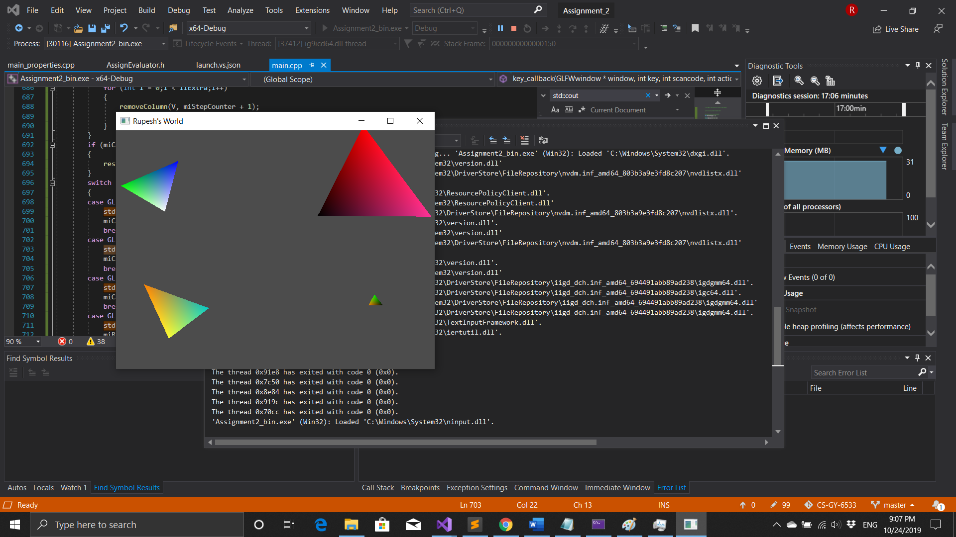

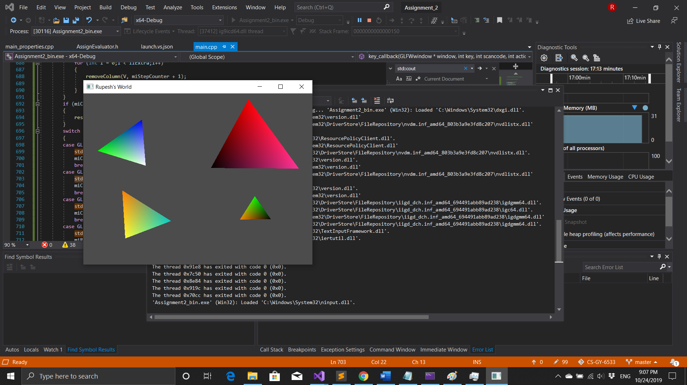

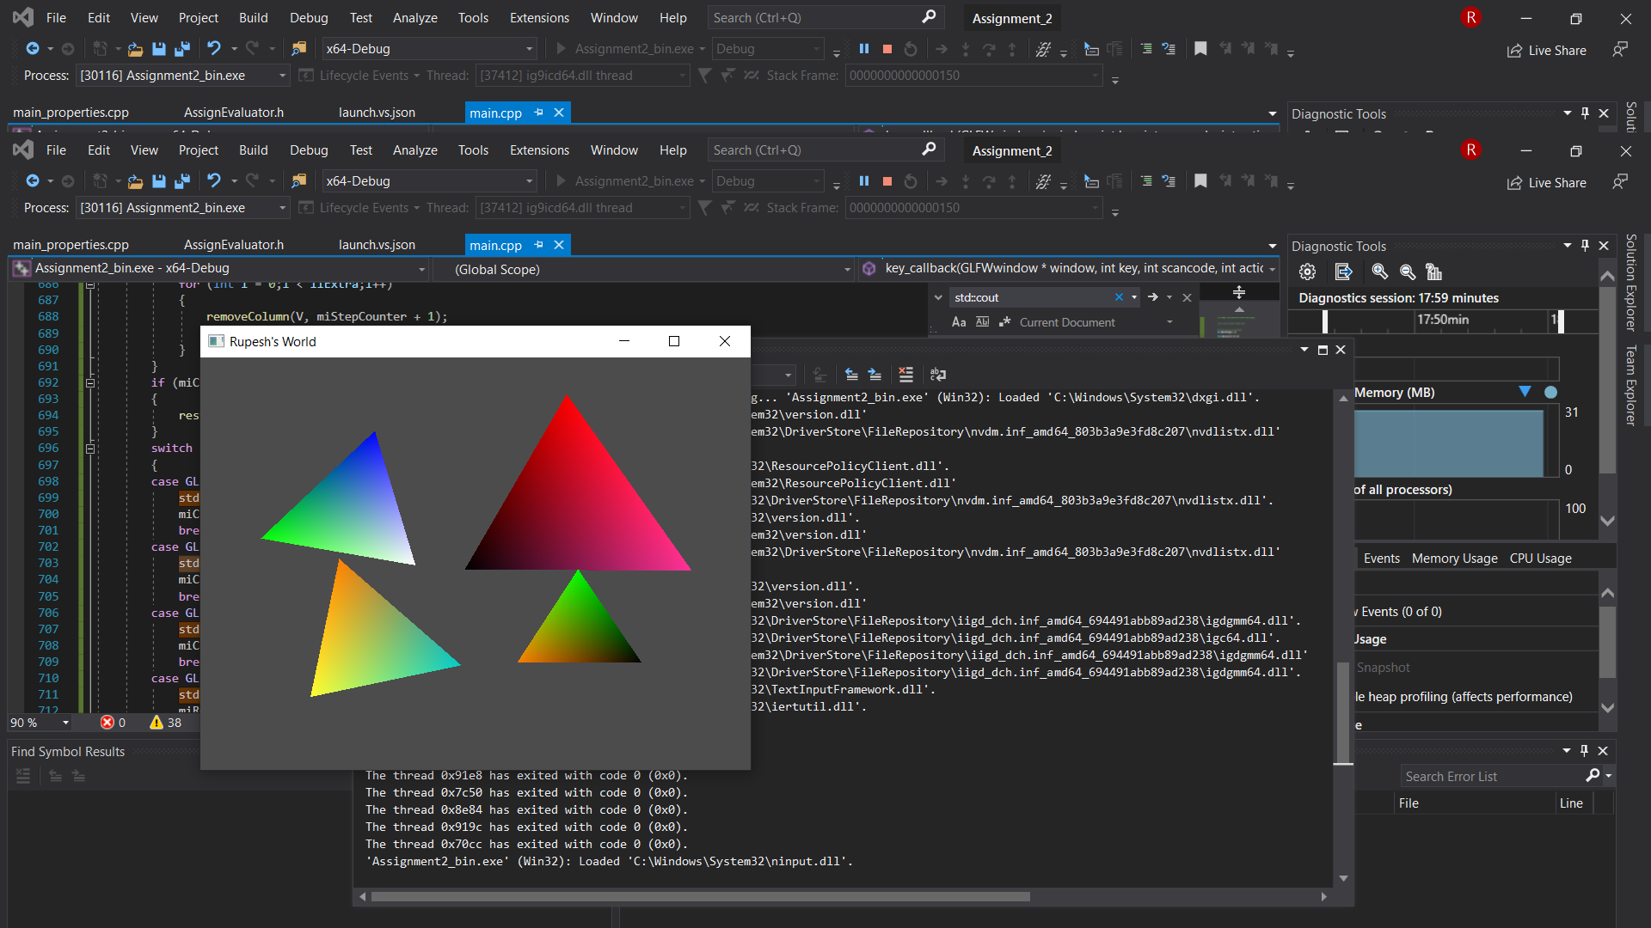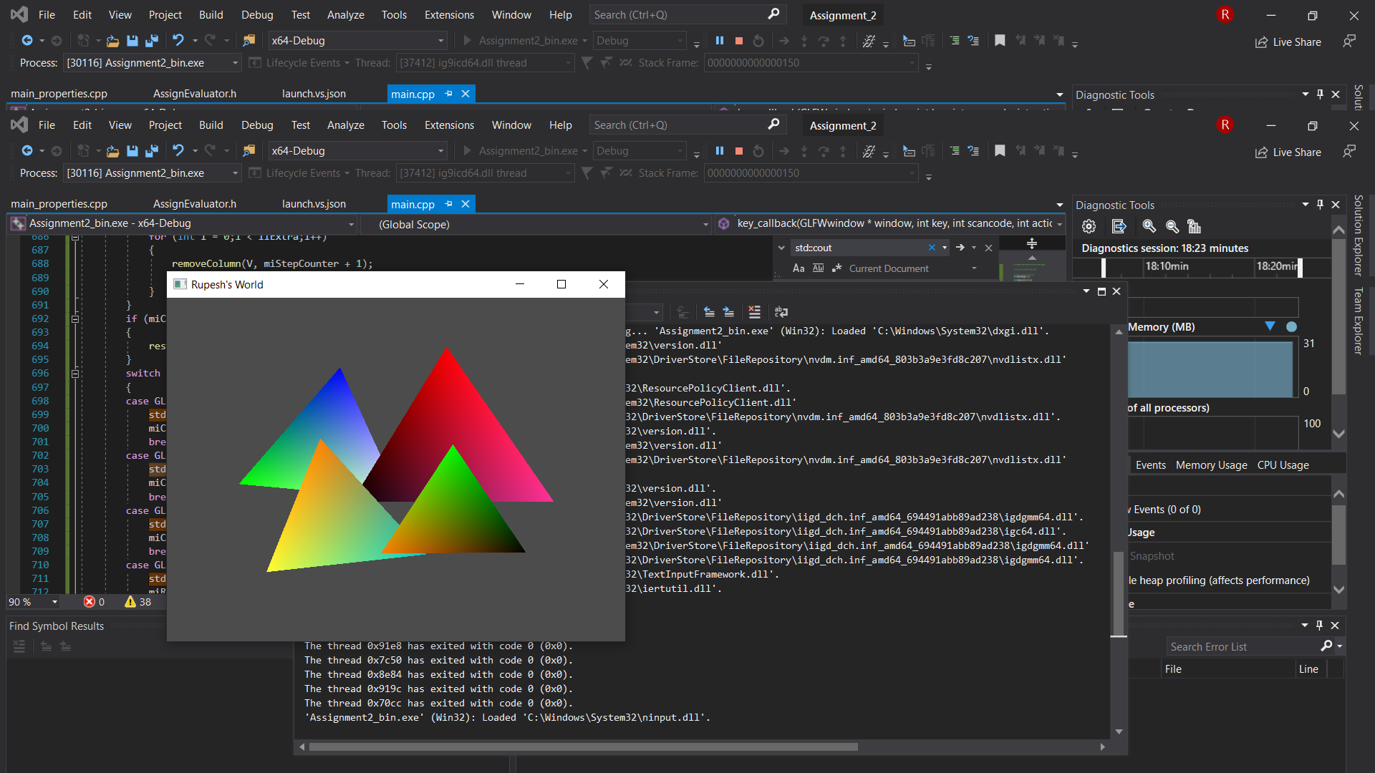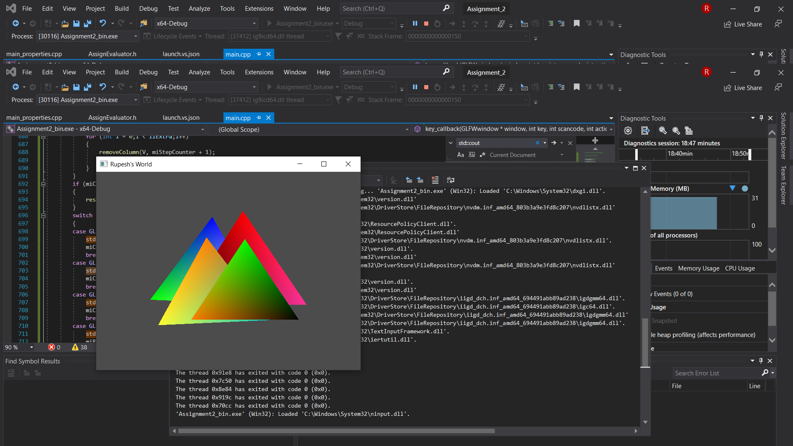

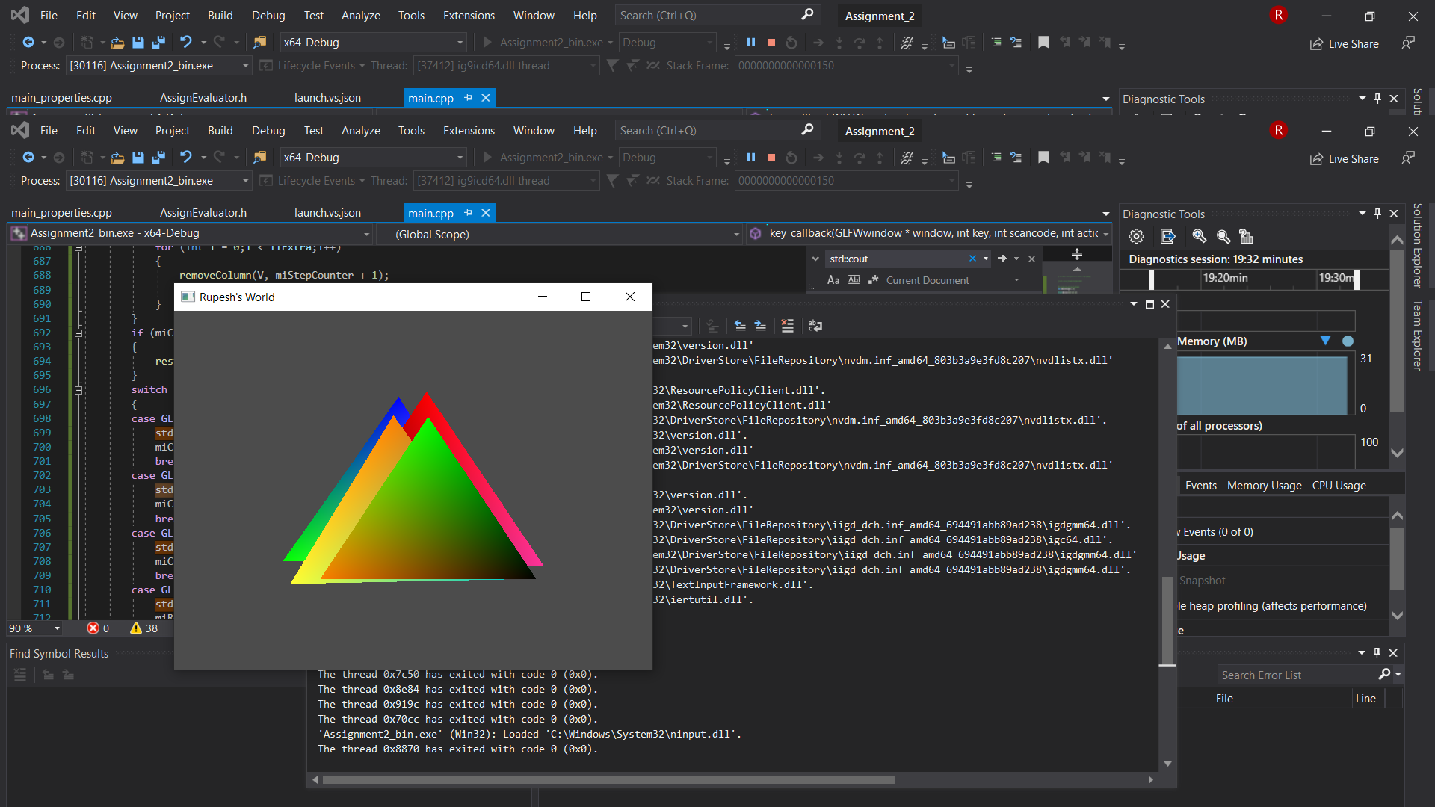

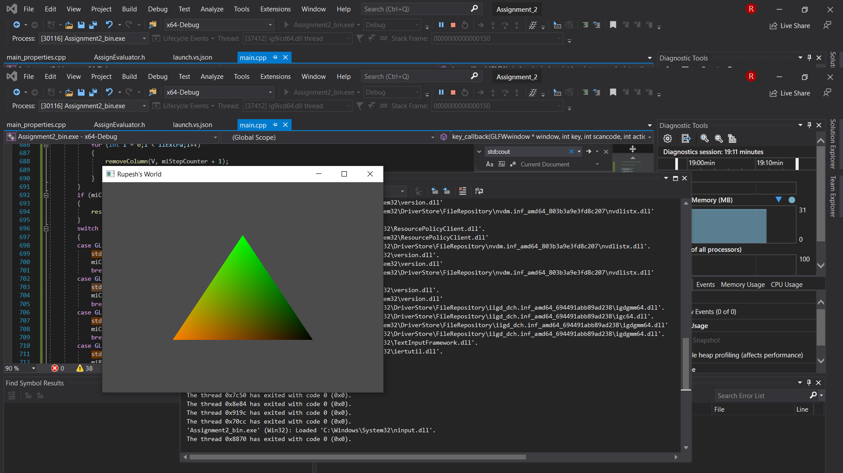



**Optional Tasks**

**Additional Primitive:- Bezier Curve**

**19)** **By pressing ‘b’ the window enters Bezier curve mode. Currently the Bezier curve is drawn on separate window. Left Mouse Button is clicked, a point is drawn. After which at another position, left button is clicked and a line gets drawn. Till this, it works similar like the triangle.**

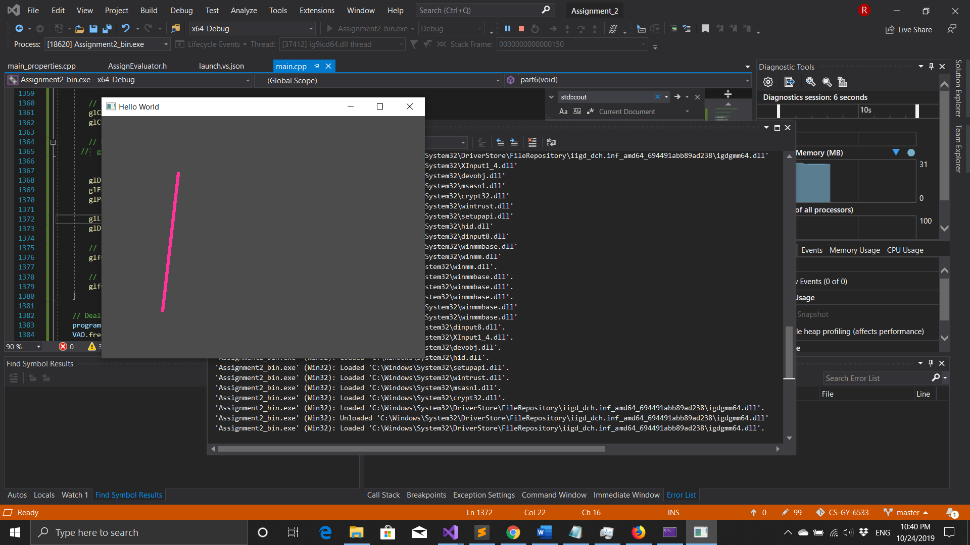

**20)** **Now cursor is moved, and third point is selected and left button is clicked and a curve is form.**

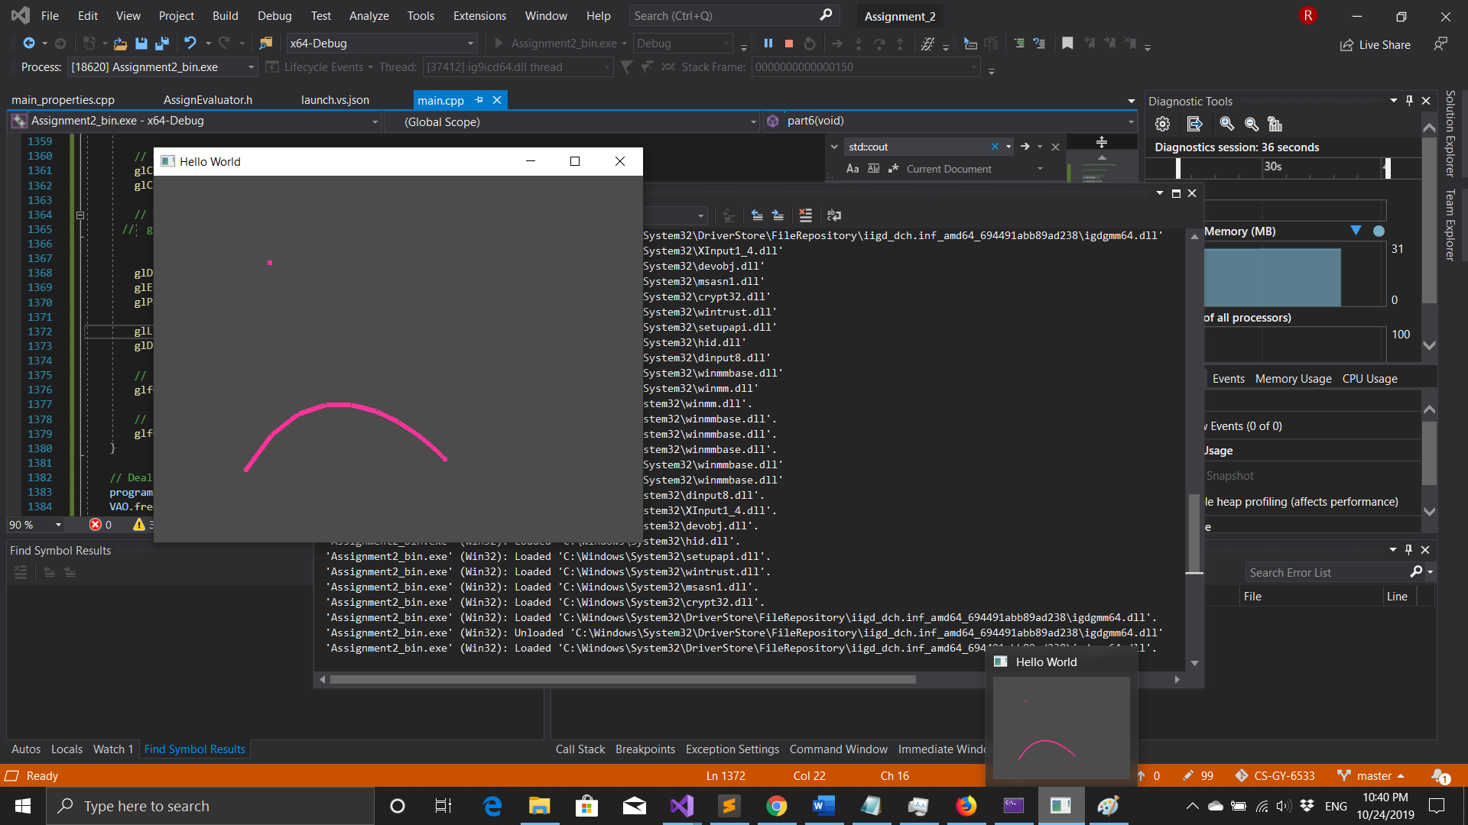

**21)** **Now similarly, fourth point is selected and left button is clicked and a Bezier curve with two control value is form.**

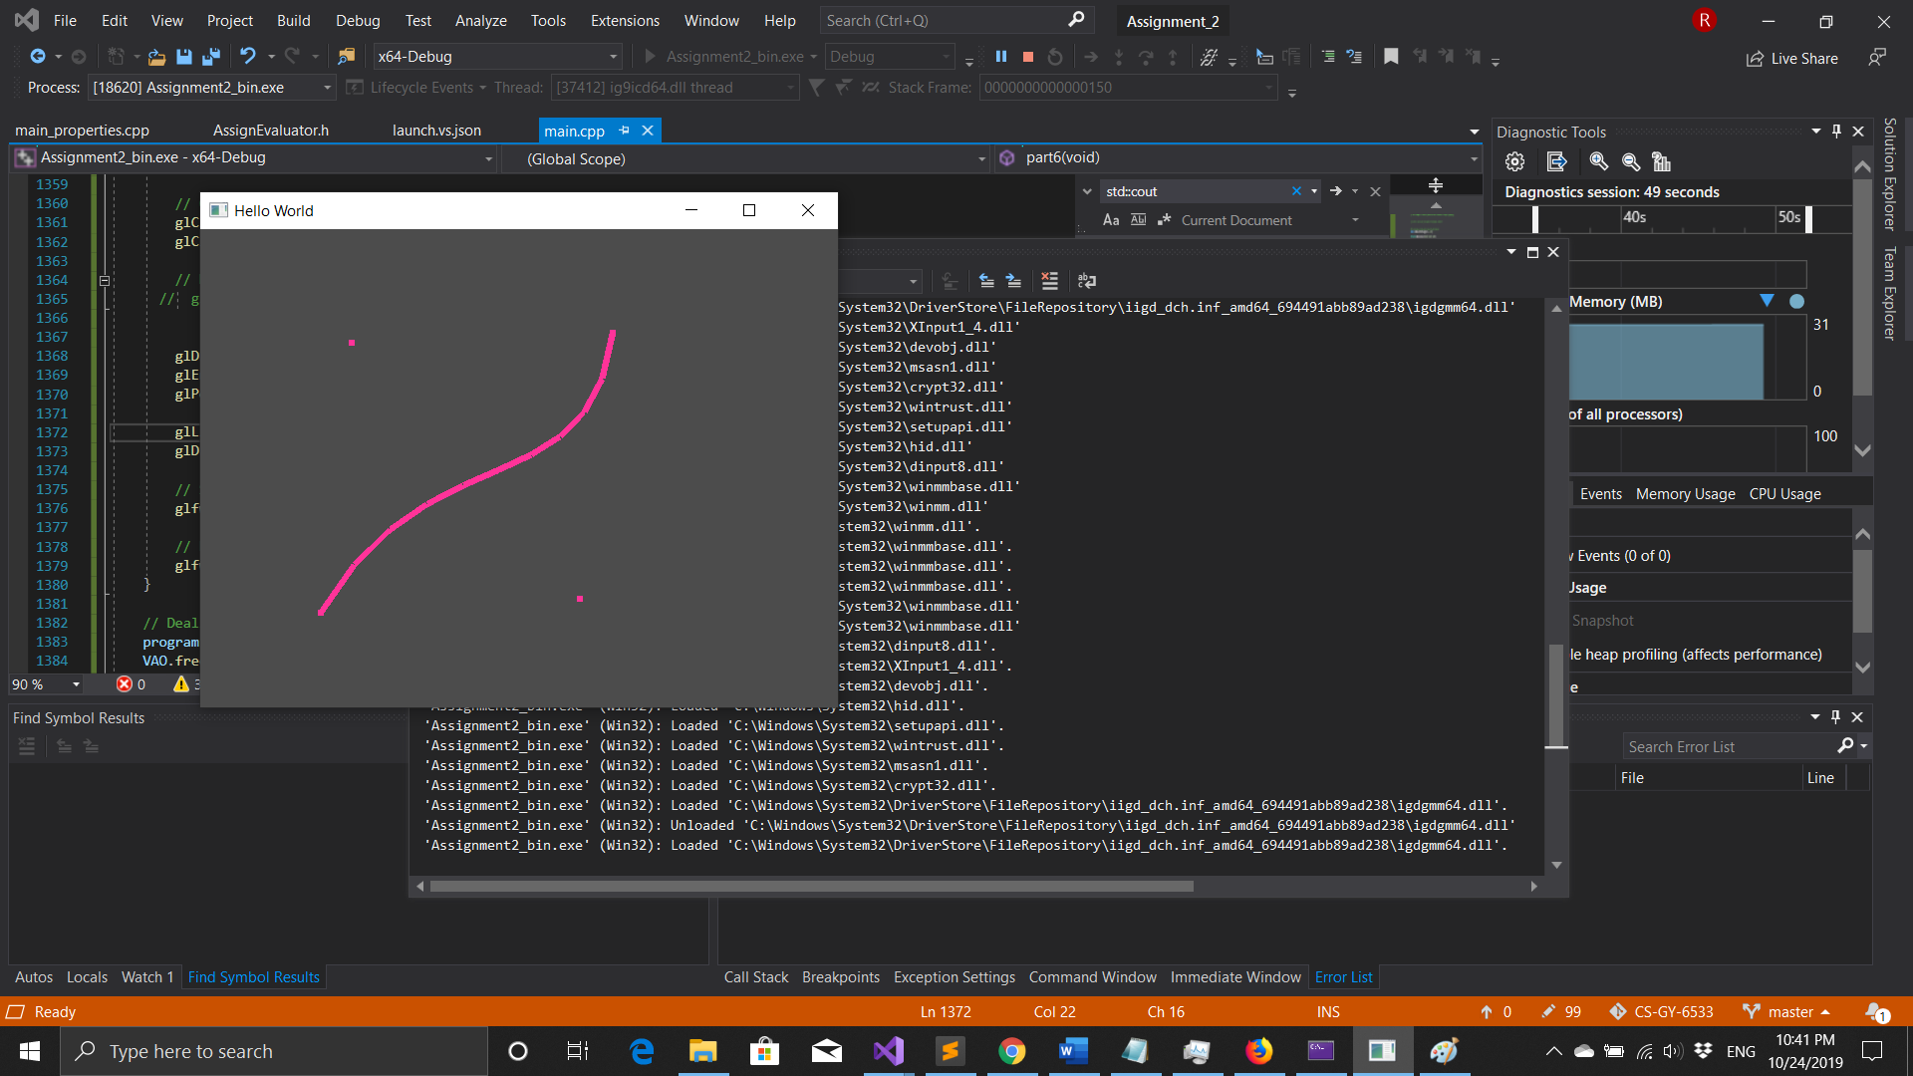

**21)** **Also, If any point you want to change, you can press ‘x’ key which would enter point selection mode and then press ‘n’ or ‘m’ to select the point, i.e. if you press ‘n’ points get selected in 1234 order while for ‘m’ it is 4321 order. Now here ‘x’ is pressed and ‘n’ is pressed and the cursor is moved to new location the first point gets moved to it along with changing the curve. Similarly the other points are moved.** 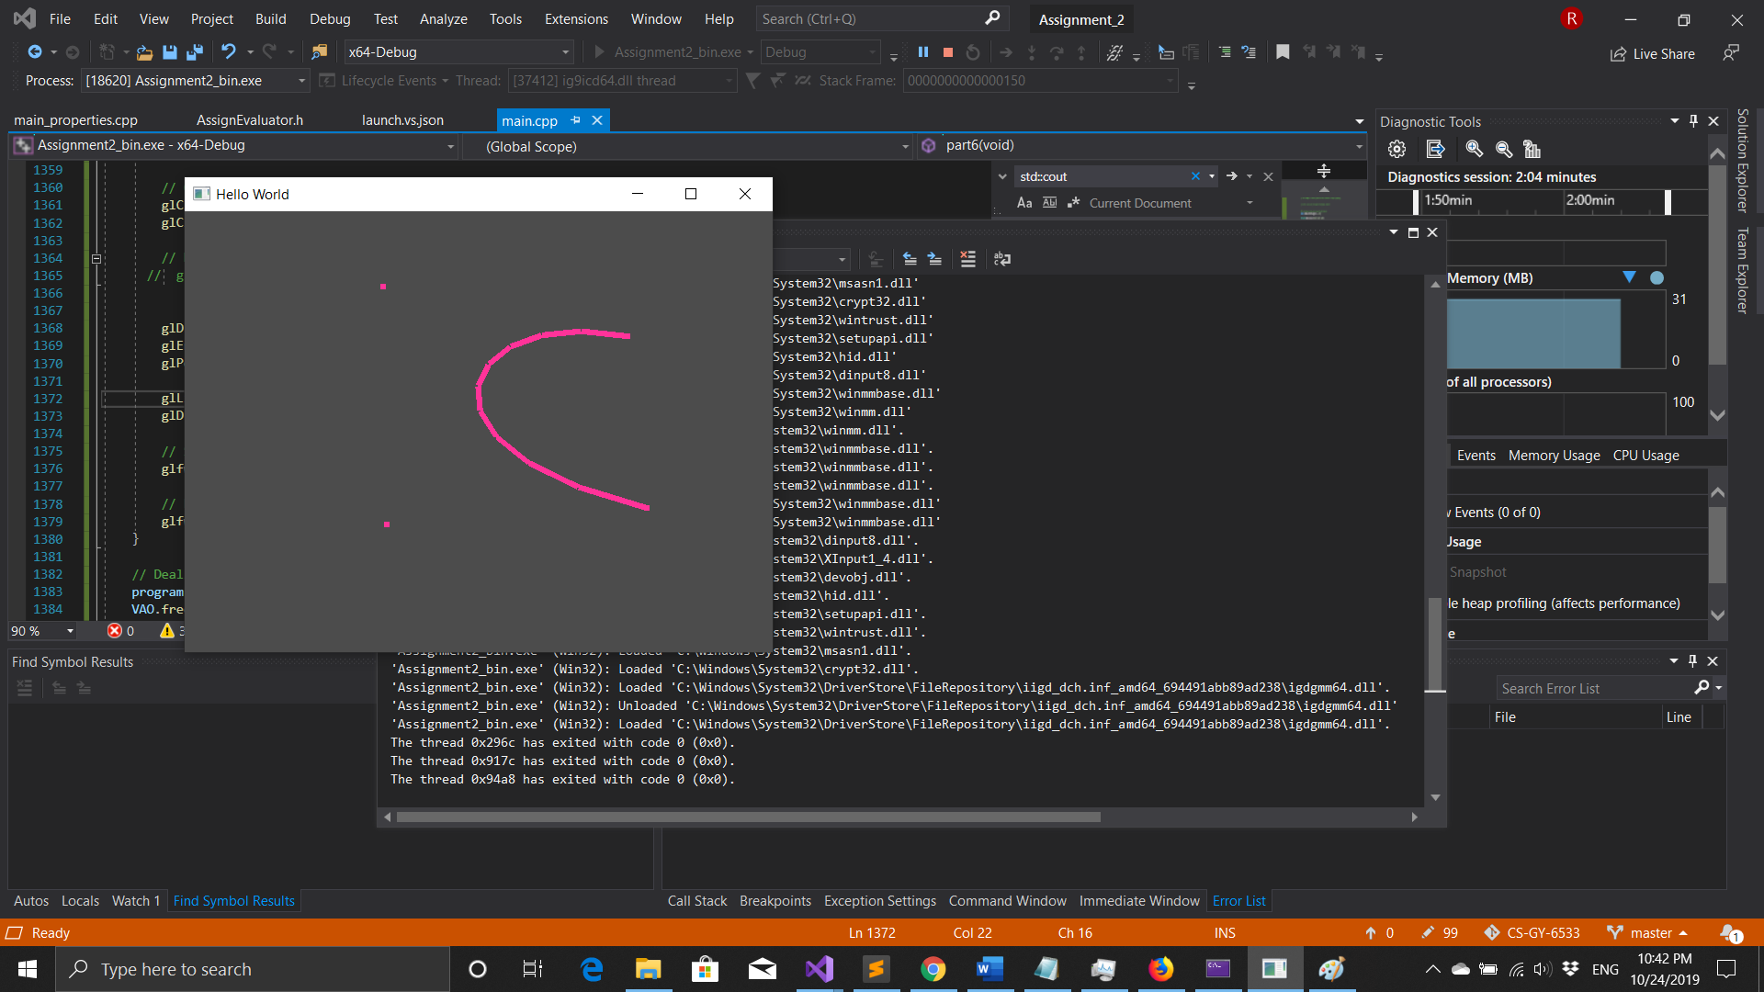

**Export in SVG format**

**22)** **By pressing ‘t’ key the window is saved in output.svg format. Currently only triangle with single color is supported. The ‘output.svg’ file is compatible with inkscape.**

***Window***

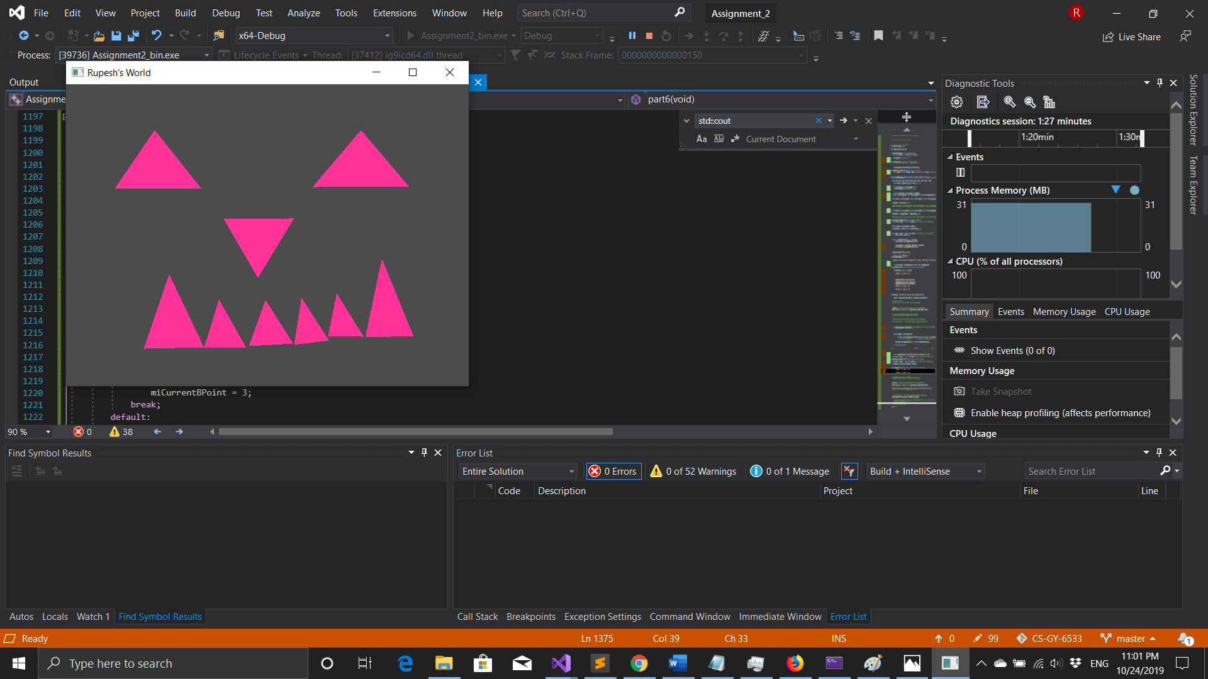

***Output.svg in IE and InkScape***

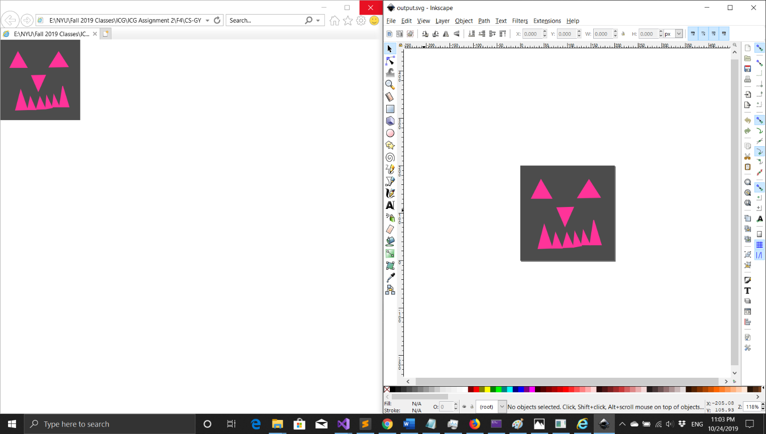

***Output.svg***

**<?xml version="1.0" encoding="UTF-8" ?><svg width = "200" height = "200" xmlns = "http://www.w3.org/2000/svg" ><rect x = "0" y = "0" width = "200" height = "200" fill = "rgb(76, 76, 76)" /><polygon points="44,30,24,69,67,69" stroke="rgb(255, 51, 153)" stroke-width="2" fill="rgb(255, 51, 153)" /><polygon points="146,30,122,68,170,67" stroke="rgb(255, 51, 153)" stroke-width="2" fill="rgb(255, 51, 153)" /><polygon points="78,89,113,88,95,128" stroke="rgb(255, 51, 153)" stroke-width="2" fill="rgb(255, 51, 153)" /><polygon points="38,175,51,125,68,174" stroke="rgb(255, 51, 153)" stroke-width="2" fill="rgb(255, 51, 153)" /><polygon points="68,174,75,142,89,174" stroke="rgb(255, 51, 153)" stroke-width="2" fill="rgb(255, 51, 153)" /><polygon points="90,173,99,142,113,172" stroke="rgb(255, 51, 153)" stroke-width="2" fill="rgb(255, 51, 153)" /><polygon points="113,172,116,140,130,169" stroke="rgb(255, 51, 153)" stroke-width="2" fill="rgb(255, 51, 153)" /><polygon points="130,167,134,137,148,167" stroke="rgb(255, 51, 153)" stroke-width="2" fill="rgb(255, 51, 153)" /><polygon points="148,167,156,115,172,167" stroke="rgb(255, 51, 153)" stroke-width="2" fill="rgb(255, 51, 153)" /></svg>**